YOUCAT YOUCAT Foundation
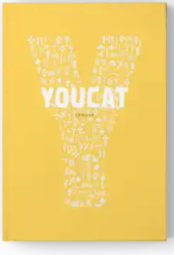
Youth Catechism of the Catholic Church

£12.95 CTS Catholic Truth Society

ISBN: 9781860827280 English addition: 2011

Description
"Many people say to me: The youth of today are not interested in this. I disagree, and I am certain that I am right. The youth of today are not as superficial as some think. They want to know what life is all about…This book is exciting because it speaks of our own destiny and so deeply engages every one of us." –
Pope Benedict XVI (Extract from the Foreword)

What does the Catholic Church teach and why? For young people today with questions about Catholicism, YOUCAT has the answers. Now the bestselling Catholic book in the world, YOUCAT is the Youth Catechism of the Catholic Church, developed with the help of young Catholics and written for secondary-school-age students and young adults.
Using clear question-and-answer format, YOUCAT offers up the entirety of the Catholic Faith, as presented in the Catechism of the Catholic Church, in an accessible and contemporary way. This is supplemented with highly-readable commentary, summary definitions of key terms, Bible and Catechism citations, and thought-provoking quotes from saints, reliable teachers of the faith, and many others.
With direct and honest questions – even at times tough – and accompanied by straightforward, relevant, and compelling answers, YOUCAT is the place for young people to go to learn the truth about the Faith.

Sample pages:

https://issuu.com/catholictruthsociety/docs/do845_youcat_final_rev/2

