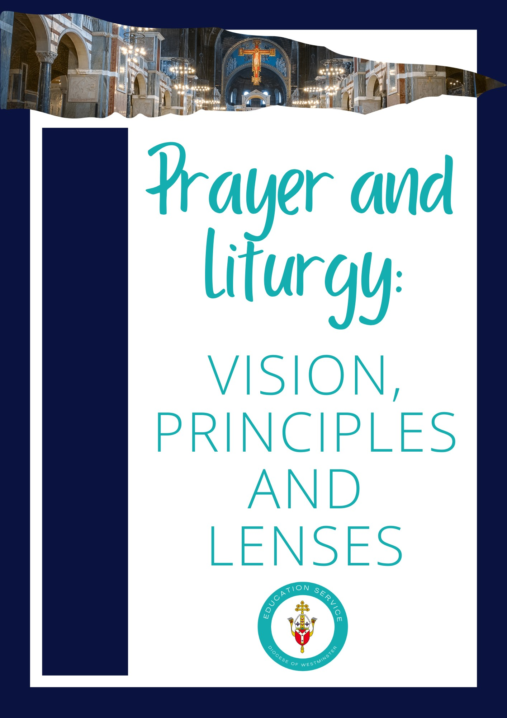

**Contents**

**Foreword………………………………………………………………………………………………………………………………………3**

**Acknowledgement and Context…………………………………………………………………………………………………….4**

**Vision for Prayer and Liturgy…………………………………………………………………………………………………………5**

**Principles for Prayer and Liturgy:**

**Invitation…………………………….………………………………………………………………………………………………………..5**

**Accompaniment………………….………………………………………………………………………………………………………..6**

**Formation…………………………………………………………………………………………………………………………………….8**

**Progressive Participation……………………………………………………………………………………….……………………10**

**Lenses for Planning Prayer and Liturgy:**

**Lens: Season………………………………………………………………………………………………………………………………..12**

**Lens: Scripture 1****4**

**Lens: Senses…………………………………………………………………………………………………………………………..……16**

**Lens: Structure……………………………………………………………………………………………………………………….……18**

**Appendix………………………………………………………………………………………………………………………………….…20**

**Foreword**

In the ever-evolving landscape of education, Catholic schools stand as beacons of faith, knowledge, and virtue. Central to their mission is the integration of prayer and liturgy into every facet of the educational experience. As we embark on a journey to explore the significance of prayer and liturgy in Catholic schools, we are reminded of their profound impact on the holistic development of students.

Prayer, the cornerstone of spiritual life, serves as a guiding light, illuminating the path towards deeper communion with God. In Catholic schools, prayer is not merely a ritual but a transformative practice that nurtures the soul and fosters a sense of belonging within the school community. Through daily prayers, students are invited to cultivate a personal relationship with God, grounding their lives in faith and trust.

Moreover, liturgy, with its rich tapestry of sacred rituals and traditions, serves as a vibrant expression of the Catholic faith within the school setting. From the celebration of Mass to the observance of liturgical seasons, pupils are immersed in the beauty and reverence of Catholic worship. Through active participation in liturgical celebrations, they encounter the living presence of Christ and are inspired to embrace lives of service and compassion.

Beyond the spiritual dimension, prayer and liturgy play a pivotal role in shaping the ethos of Catholic schools. They instil values of respect, humility, and reverence for the sacred, fostering a culture of kindness and solidarity. Through communal prayer students learn the importance of unity and cooperation, forging bonds that transcend individualism.

In conclusion, the importance of prayer and liturgy in Catholic schools cannot be overstated. They are not merely addenda to the curriculum but integral components of the educational journey, guiding pupils towards a deeper understanding of themselves, their faith, and their place in the world. As we embark on this exploration, may we be inspired by the timeless wisdom of St. Augustine, who reminds us that "to sing is to pray twice." May prayer and liturgy continue to enrich and enliven the hearts of all who walk the halls of Catholic schools, now and for generations to come.

**Rev’d Canon Michael Dunne**

**Chair - Diocesan Education Commission**

**Acknowledgements**

We extend our sincerest gratitude to the Diocese of Nottingham and Tom Baptist, the Director of Chaplaincy for Our Lady of Lourdes Catholic Multi Academy Trust for their invaluable support. Tom’s unwavering assistance has been instrumental and we are deeply appreciative of his generosity and guidance which has significantly contributed this document.

**Context**

This document has been produced by the Diocese of Westminster Education Service to help schools implement the Prayer and Liturgy Directory which was published in October 2023 and needs to be in place from September 2025. It is to be used alongside the Diocese of Westminster Education Service’s documents on Planning Prayer, Planning Celebration of the Word and Planning Liturgy.

**The Education Service Vision for Prayer and Liturgy**

The Education Service vision for Prayer and Liturgy is that -

Every opportunity for Prayer and Liturgy in our schools

offers a meaningful encounter with the living God

that reveals his transformative love and truth

and leads to a deepening of faith and action.

**The Education Service Principle for Prayer and Liturgy**

The Education Service has three principles for Prayer and Liturgy -

Invitation, Accompaniment and Formation

Invitation

The first principle for Prayer and Liturgy is Invitation

*’Jesus turned and saw them following and said to them, “What are you seeking?”*

*And they said to him, “Rabbi” (which means Teacher), “where are you staying?”*

*He said to them, “Come and you will see*.”’

(John 1:38-39)

Jesus began his ministry by inviting people from different backgrounds to come and follow him. Inviting participation in Prayer and Liturgy, like Jesus did, promotes conscious, sincere, and authentic engagement. Schools are also diverse communities which respect the dignity and integrity of each person so participation in Prayer and Liturgy should be invitational, particularly for those of other faiths and none.

## **Questions to consider:**

* How does your school’s invitations to Prayer and Liturgy affirm the value and worth of the Catholic faith?
* How does your school invite the Catholic members of your community to participate and lead Prayer and Liturgy?
* How does your school invite staff to lead or facilitate Prayer and Celebrations of the Word?
* How and when does your school ensure pupils of other religions can pray in their tradition?
* How does your school consider including pupils of other religions and none and yet ensure prayer remains in the Catholic tradition?
* When is a class rota appropriate in your school?

Accompaniment

The second principle for Prayer and Liturgy is Accompaniment

‘*That very day two of them were going to a village named Emmaus,*

*about seven milesfrom Jerusalem, and they were talking*

*with each other about all these things that had happened.*

*While they were talking and discussing together,*

*Jesus himself drew near and went with them*.’

(Luke 24:13-15)

Jesus had originally invited the disciples to follow him, but he did not stop there even as these two disciples were walking away from all they had experienced in his company; he came to walk alongside them, guiding them as they grew in understanding of their faith and capabilities. Likewise, Prayer and Liturgy offers schools a chance to walk alongside and guide pupils and staff in their faith journeys, gently directing them towards God’s plan for them.

The way each school accompanies its pupils and staff will be rooted in the school’s unique charism. This will include the day to day opportunities for accompaniment in Prayer and Liturgy but will also include accompanying those in the school community in times of joy and sorrow. Ultimately, accompaniment during all these times should lead to making Christ known.

## **Questions to consider:**

* When and how does Prayer take place in your school?
* How does Prayer help your school accompany pupils, staff and parents at specific times, for example: at the start of the year, during a time of bereavement?
* How does your school accompany all pupils and staff with Prayer and Liturgy – those with a deep faith or none?
* How does your school accompany those who are keen to volunteer and those who are indifferent?
* How does your school accompany all staff – the site team, cleaning staff, catering staff…
* Who accompanies those teachers leading Prayer and Liturgy?
* How does your school environment support accompaniment?
* How does your school accompany pupils and staff who are not Catholic?

Accompaniment of those of other religions or none

‘Nevertheless, in our dealings with people, we must not lose pastoral charity,

which should permeate all our decisions and attitudes.

The defence of objective truth is not the only expression of this charity;

it also includes kindness, patience, understanding, tenderness, and encouragement. Therefore, we cannot become judges who only deny, reject, and exclude.’

(Pope Francis, Reposta Dubia, July 2023)

Throughout any interactions, it is essential to be attuned to the needs of pupils and staff, including those of other religions and none. By engaging in sensitive dialogue and upholding each person's dignity, we can establish what is appropriate and seek opportunities to celebrate shared values.

Formation

Our third principle for Prayer and Liturgy is Formation

‘My child, be attentive to my words;  
    incline your ear to my sayings.  
Let them not escape from your sight;  
    keep them within your heart.  
For they are life to those who find them,  
    and healing to all their flesh.  
Keep your heart with all vigilance,  
    for from it flow the springs of life.’

(Psalm 4:20-23)

Too often staff and pupils are hesitant to participate or lead Prayer and Liturgy as they worry they will get it wrong. Formation can help build confidence but what is formation? Formation should be a lifelong process that enables a person’s faith to grow and deepen.

Without probably realising it, Catholic staff have all received and provided formation. They have been formed in the beliefs, words, celebrations and actions of the Church, maybe informally from family or teachers, or formally in parish church classes. Teachers also formed through the process of formation by answering questions from pupils about why Catholics believe, celebrate or do certain things, for example: genuflecting in church.

Schools need to provide these informal and formal moments of formation for pupils and staff to help develop their faith. This means that time should be spent ensuring pupils and staff know and understand what will happen during times of Prayer and Liturgy. This in turn can make the Prayer and Liturgy itself formative, for example when pupils understand as readers they are proclaiming God’s words they then pay closer attention to what they are reading.

It is important that schools plan formation carefully for staff and pupils. This could involve progressively teaching pupils how to pray or leading formation sessions for those pupils who, for example: will be reading at Mass. Opportunities for deliberate, and high-quality formation programmes should be provided to ensure that those who serve others in Prayer and Liturgy have the knowledge and understanding to lead with confidence and care. Beneath is a suggested plan of formation which should be used in partnership with Progression Participation:

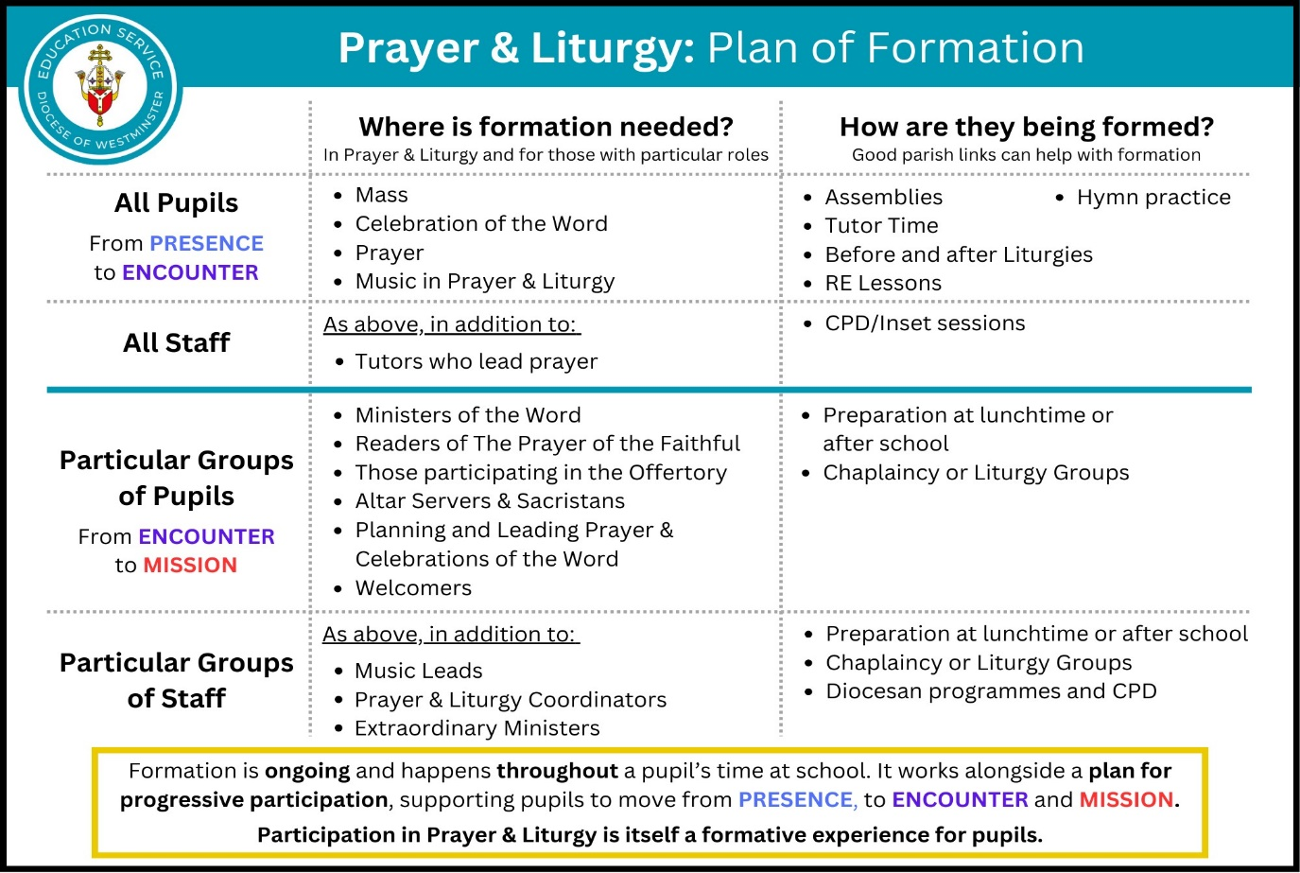

## **Questions to consider:**

* Where do you see informal formation taking place in your school?
* How does your school community ensure an understanding of the importance of Mass?
* How does your school support teachers to create opportunities for Prayer?
* How does your school guide your pupils to participate in Prayer and Liturgy?
* How are pupils formed for liturgical ministry?
* In what ways is your school’s CPD formational?
* What is the role of your school’s Prayer and Liturgy leader in regards to formation?
* How is ongoing formation provided for school leaders?

**Progressive Participation**

Prayer and Liturgy also involve progressive participation but what does this mean?

Progressive participation in Prayer and Liturgy refers to the gradual deepening of engagement and service. This means not just going through the motions, but growing in understanding, experience and devotion. This progression includes increased knowledge, a deeper understanding of the theological significance, and a more profound encounter with God during participation. It is a journey of ongoing growth and response to Prayer and Liturgy.

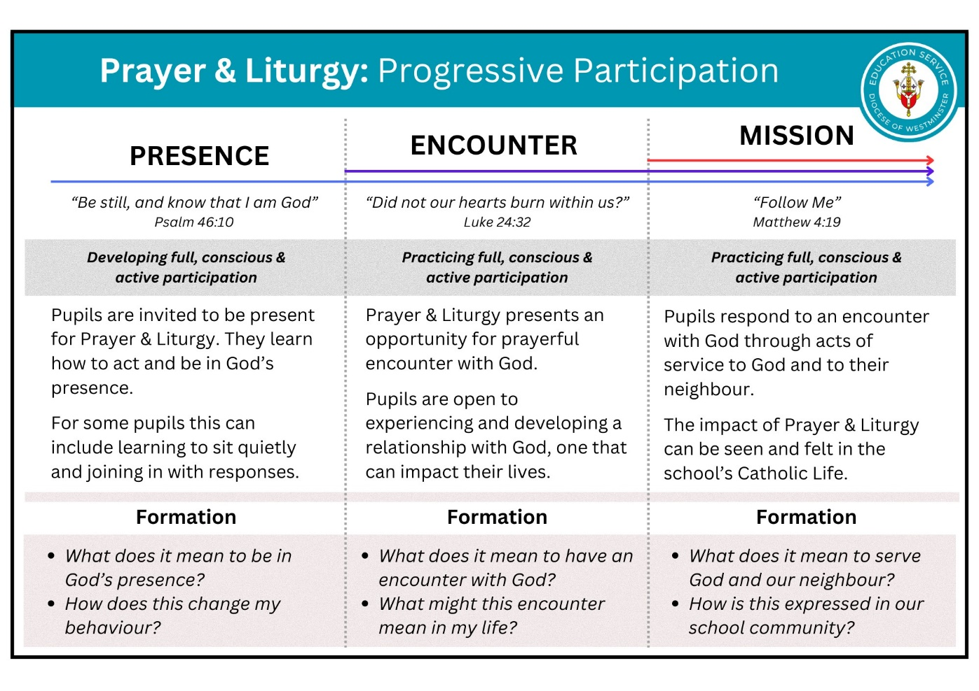To participate ’fully’ means having an awareness that liturgical celebration happens together, as a school and wider Church community. Participating ‘consciously’ is underpinned by good formation, where pupils have an understanding of what is happening in the liturgy. Finally, participating ‘actively’ means entering into liturgy with an openness to prayerful encounter with God, acknowledging the impact it can have on their lives.

The table above is a demonstration of progressive participation that is not linked to age, so is suitable to be used in Primary, Secondary and Sixth Form contexts. It is intended that this model for progressive participation can help to define your school’s plan for student formation.

## **Questions to consider:**

* Consider which of your pupils are at each stage of Progressive Participation?
* How does your school support pupils to move from presence to encounter and from encounter to mission?
* In your school are there patterns that could be identified regarding Progressive Participation? How could the school maximise and address these patterns of participation?

The three principles for Prayer and Liturgy - Invitation, Accompaniment and Formation and Progressive Participation are symbiotic but they must also be authentic and deliberate if Prayer and Liturgy is to ‘offer meaningful encounter with the living God that reveals his transformative love and truth and leads to a deepening of faith and action.’

**The Education Service Lenses for Planning Prayer and Liturgy**

There are four lenses which should be used when planning Prayer and Liturgy to ensure:

‘every opportunity for Prayer and Liturgy in your schools offers a meaningful encounter with the living God that reveals his transformative love and truth and leads to a deepening of faith and action.’ The four lenses are -

**Season, Scripture, Senses, Structure**

These lenses complement each other and should be used when preparing Prayer, Celebrations of the Word and Liturgy.

Season

‘By means of the yearly cycle, the Church celebrates the whole mystery of Christ, from his incarnation until the day of Pentecost and the expectation of his coming again.’ (CCC 1194)

Consideration of the liturgical season in planning and celebrating Prayer and Liturgy is crucial. Just as the changing seasons in nature mark the passage of time, the liturgical seasons of the Church should also feel distinct. By aligning liturgical practices with the rhythm of the Church's calendar, we connect with the Universal Church and enrich Prayer and Liturgy in our school communities.

This can be done in a number of ways and the senses section later will give more inspiration for the different ways to mark the seasons of the liturgical year. The different seasons also provide an opportunity for pupils and families to share how Catholics from around the world mark these important events in varying ways.

School communities should also consider the seasons of the academic year: often teachers are fresh and enthusiastic at the start of the year, jaded and irritable in the dark winter months, anxious but hopeful in Spring, shattered but satisfied in the summer! Pupils also go through seasons during the academic year and their time at school, when they first join the school or a new class, exam season, moving on a year or leaving the school. There are also the seasons in society, for example Remembrance Day or Black History Month. The Prayer and Liturgy used in schools should acknowledge and accompany these seasons too.

## **Questions to consider:**

* How do you mark the liturgical seasons in your school?
* How do you mark the academic seasons in your school?
* How do you mark the seasons in society?

Season – Application

Here are some suggestions of ways you can use the lens of season in Prayer and Liturgy.

* **Liturgical Colours**

The visual cues provided by liturgical colours aids in the formation of Catholic identity and understanding of the Church’s beliefs and traditions. Liturgical colours carry symbolic meanings that reflect the seasons. By using these colours, there is a visual connect with the religious significance of each liturgical season. Consistent use of liturgical colours also fosters a sense of unity within the school and connects with the wider Church. In addition, liturgical colours contribute to the aesthetic beauty of Prayer and Liturgy. They create a sacred atmosphere and enhance the experience by making it engaging and meaningful. Some examples are the use of cloth, display paper, lighting.

* **Consult the** [**Diocesan Annual Ordo**](https://rcdow.org.uk/att/files/liturgical%20calendar/liturgical%20calendar%202024.pdf)

The Diocesan annual Ordo outlines the calendar of celebrations in the diocese and provides guidance for formal liturgies. This includes details on the liturgical season, feast days, readings, and specific instructions for celebrating Mass.

* **Annual Plan of Provision**

As outlined in the Directory, the Annual Plan of Provision (APOP), gives clarity and structure to Prayer and Liturgy in each school. The starting point each year for the APOP is the Liturgical Calendar. It should contain an academic calendar, with the liturgical seasons, feasts, events, and celebrations that will be marked by the school. As a result, it will also include when Prayer, Celebrations of the Word and Liturgy will take place. Each year, it is essential to review and evaluate the APOP, to ensure it continues to support and develop the provisions of Prayer and Liturgy for all in the school community.

Scripture

‘Well-chosen scripture passages that are informed by the liturgical season

form the heart of Prayer and Liturgy’ (CSI Descriptors, page 34)

The foundation of Prayer and Liturgy is scripture. Engaging with scripture, especially the Gospels, provides an opportunity to meet Jesus, the Word made flesh. Therefore, thoughtful selection of scripture makes God’s word come alive.

## **Questions to consider:**

* How does your school use scripture?
* How is scripture selected?
* How is scripture integrated in to the school day?
* How is the importance of scripture emphasised in school?
* What rituals do pupils in your school associate with scripture?

Scripture - Application

* **Use the Daily Readings from the** [**Diocesan Annual Ordo**](https://rcdow.org.uk/att/files/liturgical%20calendar/liturgical%20calendar%202024.pdf)

The Church provides us with a rich calendar of daily readings which narrate the liturgical year, through the different liturgical cycles. These are an excellent starting point for selecting scripture for Prayer and Liturgy. As mentioned previously, the Ordo gives the specific readings for each day and is essential for the planning of Mass. [Universalis](https://universalis.com/mass.htm) also provides the daily readings.

* **Scripture is at the very heart of any Celebrations of the Word**

Scripture is the foundation and not the finishing touch so in planning Celebrations of the Word start with scripture and plan from there.

* **Scripture in the Wider Life of the School**

It is important to find ways of sharing and incorporating scripture not just in Prayer and Liturgy but also into the wider life of the school. Consider the varied places that scripture could be used and visible in the school, such as in reception, the canteen, offices, communication, varying curriculum areas, on displays and in sacred spaces. This is a powerful way to show how scripture informs every aspect of our lives.

* **Use a Catholic edition of the Bible**

To ensure consistency use a Catholic edition of the Bible. There are a number of characteristics of a Catholic edition:

* It includes the deuterocanonical books. These are texts in the Old Testament where there is an ancient Greek Jewish source but not a Hebrew one. These include Tobit, Wisdom, Sirach and Baruch. They have always been accepted by the Catholic Church as part of the Canon of Scripture.
* The translation reflects a Catholic understanding of scripture
* The translation has received an imprimatur from a Bishops’ Conference
* There should be study notes to assist the reader.

In primary schools the Good News Translation should be chosen as it has been produced to be accessible to primary school pupils. In Year 6, begin to introduce the English Standard Version (ESV) but comparing it to the Good New Translation. The aim in Year 6 is a full transition to using the ESV because it is what pupils hear being read from in the Lectionary. In secondary schools, use the ESV Bible.

The Senses (See, Hear, Think, Do)

‘Existential engagement happens — in continuity with and consistent with the method of Incarnation — in a sacramental way.

The Liturgy is done with things that are the exact opposite of spiritual abstractions: bread, wine, oil, water, fragrances, fire, ashes, rock, fabrics, colours, body, words, sounds, silences, gestures, space, movement, action, order, time, light.

The whole of creation is a manifestation of the love of God, and from when that same love was manifested in its fullness in the cross of Jesus, all of creation was drawn toward it.

(Desiderio Desideravi, 42)

Jesus was incarnate – fully God and fully human. Jesus took on flesh and used his senses:

‘And Jesus said, “Who was it that touched me?” … “Someone touched me, for I perceive that power has gone out from me. “Who has touched me” (Luke 8:45-46) or ‘Having said these things, he spit on the ground and made mud with the saliva. Then he anointed the man's eyes with the mud…’ (John 9:6)

God has also created us as physical beings who experience his creation through our senses. These senses are also used during Mass to make the abstract concrete, for example: making the sign of the cross on our heads, lips and heart before the Gospel is read.

It is therefore important that we consider and plan for the senses - what we see, hear, think and do during times of Prayer and Liturgy. By including the senses we make prayer and liturgy accessible and engaging to all.

The Senses – Application

Here are some suggestions to support the different senses -

**See**

Prayer focus/Altar (Liturgical colours) Video

Candle/Crucifix Liturgical dance

Icon/Object Procession

Song lyrics Artwork/statue

Bible (Scripture) Quote

Drama

**Hear**

Silence Prayer

Music Story

Scripture Words of Wisdom/Quotes

Explanations

**Think**

How they can carry out the mission Reflection time

Links with saints/iconic people Questions

Links with other scripture Prayers

Links with school themes/mission/virtues/CST Meditation

Link with current events

**Do**

Sing a hymn or song Actions to a song

Gospel Acclamation Sign of peace

Washing hands/feet Symbolic gesture

Posture - bowing heads, closing eyes, standing… Liturgical dance

## **Questions to consider:**

* How does your school incorporate the sense of sight in Prayer and Liturgy in your school?
* How does your school incorporate the sense of hearing in Prayer and Liturgy in your school?
* How does your school incorporate the sense of thought in Prayer and Liturgy in your school?
* How does your school incorporate the sense of doing in Prayer and Liturgy in your school?

In addition, consider these other ways to support the lens of the senses:

* **Symbols**

Thoughtful symbols used in Prayer and Liturgy help to make experiences of Prayer and Liturgy distinct, important and meaningful. They also help those present to understand the deeper meaning, for example: using a nail, during Holy Week could help remind those present of Jesus’ suffering.

* **Rituals, Gestures and Actions**

Consider the rituals, gestures and actions that can be used to enhance experiences of Prayer and Liturgy such as turning to face a prayer focus in the classroom, bowing heads, the sign of the cross or genuflection - these all can help pupils understand beliefs.

* **Physical Environment**

Clearly a change of physical environment helps immensely with making Prayer and Liturgy meaningful – a chapel, an off-site retreat centre, changing how the pupils are seated or the lighting… are all going to aid in making Prayer and Liturgy significant and special.

Structure

‘Having a rhythm to life, grounded in prayer and reflection helps to guide the wandering mind, uplifts the burdened soul, and unites the faithful in communion with God.’ (Unknown)

Structures are essential to making a school work and creating purpose and security for staff and pupils. The same applies to Prayer and Liturgy: it must be carefully structured to compliment the liturgical year and develop familiarity and comfort.

We structure Prayer and Liturgy by creating a rhythm for it each day/week/term/year. This rhythm mirrors that of the Church and reassures and gives staff and pupils confidence in regards to Prayer and Liturgy. Over time, this then allows for a deep and meaningful engagement with Prayer and Liturgy in the school.

However, like all structures, it is crucial to be intentional and thoughtful when shaping a rhythm for Prayer and Liturgy in schools. It must resonate with the charism of your school and be accessible and engaging.

## **Questions to consider:**

* Who is involved in planning the structure each year, term, month?
* How do you structure Prayer and Liturgy in your school each day, week, term, year?
* How does the structure demonstrate the importance of Prayer and Liturgy in your community?
* How does the structure you use for Prayer and Liturgy reflect the charism and context of your school?
* How does your structure allow for flexibility?
* How does your structure provide a sense of community and togetherness in the school?
* How well understood is the structure by all members of the school community?
* How is the structure communicated to all in the community, including families and the parish?

Structure – Application

* **Prayer and Liturgy Policy**

Each school should have a Prayer and Liturgy Policy. The policy provides clear guidelines and expectations for all staff and governors regarding Prayer and Liturgy and this fosters accountability. It also ensures there are high expectations in regards to Prayer and Liturgy and this will contribute to ensuring the school is fulfilling the mission of the Church to make Christ known.

Please see the appendix for a model Prayer and Liturgy Policy.

* **Annual Plan of Provision (APOP)**

The APOP, as explained earlier, is central to the structuring of Prayer and Liturgy in schools and when applied will create a unique rhythm to what the school does.

Here is a suggested overview for the structure and rhythm for Prayer, Celebrations of the Word and Liturgy. (Remember the daily ‘act of worship’ can be a prayer, a Celebration of the Word or a Liturgy).

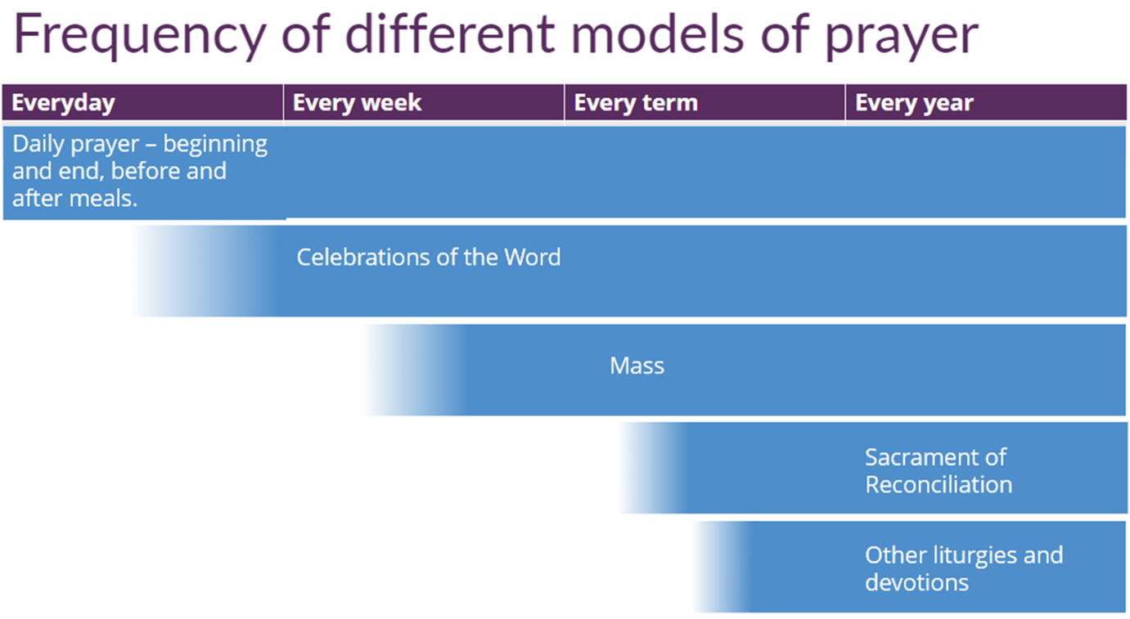

* **The four-part structure - Gather, The Word, Response, and Mission**

Other deliberate and effective structures also help us connect with the tradition of the Church. The four-part structure of - Gather, The Word, Response, and Mission used in the Mass serves as a model for the planning of Celebrations of the Word (this includes assemblies, retreats, services etc) and develops understanding.

Please see the appendix for a model planning sheet for the four-part structure for a Celebration of the Word.

* **School Traditions and Rituals**

School traditions and rituals also help to create a structure and rhythm to Prayer and Liturgy in the school. Some are present in all Catholic schools, for example: making the sign of the cross before prayer or learning and using traditional prayers. Others will be specific to each school, for example: a school prayer/hymn or the tradition of giving a candle and praying for new teachers who have joined the school. These school traditions and rituals create a reassuring rhythm and contributes to uniting the school community.

However, be mindful that the structure and rhythm for Prayer and Liturgy must not become meaningless or purely functional. Instead, they should be rich and relevant opportunities for Prayer and Liturgy, for example: sung grace each Friday, The Examen every Monday, a prayer intentions wall, silence etc… And these opportunities must be regularly reviewed to make sure they provide ‘meaningful encounter with the living God that reveals his transformative love and truth and leads to a deepening of faith and action.’

**Appendix**

Prayer and Liturgy Policy

[Name of school and/or logo]

**Prayer and Liturgy Policy**

This prayer and liturgy policy has been approved and adopted by the governing body on [enter

date] and will be reviewed on [enter date].

Signed by the Chair of Governors

Signed by the Headteacher

[School mission statement]

1. The context of this prayer and liturgy policy

‘The celebration of Catholic liturgies and prayers as an integral part of the learning and

teaching should enable the school community to become reflective, experience the

presence of God and should develop a mature spiritual life.’ (Marcus Stock (2012), Christ

at the Centre, Catholic Truth Society, 23.)

2. Statement of requirement

The law requires all maintained Catholic schools to provide an act of daily collective

worship (prayer and liturgy) for all pupils, including those in the sixth form (Section 70, 1988

Education Act) that is in accordance with the rites, practices, disciplines, and liturgical

norms of the Catholic Church (School Standards and Framework Act 1998, schedule 20;

70 Instrument of Government, clause 2). Academies in England are required by their

funding agreement and Articles of Association to comply with similar requirements (The

Mainstream Academy and Free School: Supplemental Funding Agreement, December

2020; Model Articles for Catholic Academies, February 2019).

The law requires all maintained schools to recognise and respect that parents have the

legal right to withdraw their children up to the age of 16 from prayer and liturgy (School

Standards and Framework Act 1998, s.71(1A)). Sixth-form pupils can choose to withdraw

themselves from prayer and liturgy (School Standards and Framework Act 1998, s.71(1B)).

The school’s provision for prayer and liturgy will fulfil pupils’ entitlement to experience the

range of liturgical treasures of the Church, including a shared repertoire of prayers and

liturgical music with which pupils in the school will be familiar.

Prayer and liturgy are not designated curriculum time. In the context of the Catholic school,

this means that times of prayer and liturgy are not considered to be part of the allocation

of curriculum time for Religious Education.

3. Responsibility

(a) Governance

The governors, as guardians of the Catholic school’s life and mission, have a responsibility

to ensure that:

• prayer and liturgy are central to the Catholic life of the school and therefore are in line

with the guidance set out by the Prayer and Liturgy Directory

• there is a named person(s) who is responsible for prayer and liturgy in the school (the

Prayer and Liturgy Coordinator)

• the prayer and liturgy policy is updated regularly and shared with all stakeholders

• there is a budget for prayer and liturgy that reflects its centrality to the life of a

Catholic school.

(b) Headteacher

The headteacher, as the spiritual leader of the school as a Catholic community,

ensures that:

• prayer and liturgy are central to the Catholic life of the school and therefore are in line

with the guidance set out by the Prayer and Liturgy Directory

• they work in partnership with the leader(s) for prayer and liturgy

• those responsible for prayer and liturgy in the school have been given appropriate

training and formation to ensure that all guidance is followed and adhered to

• there are suitable resources for prayer and liturgy in the school.

(c) Prayer and Liturgy Coordinator

Those responsible for prayer and liturgy ensure that:

• prayer and liturgy are central to the Catholic life of the school and therefore are in line

with the guidance set out by the Prayer and Liturgy Directory

• there is an Annual Plan of Provision for prayer and liturgy across the school year which

identifies liturgical seasons and key celebrations, as well as opportunities for the

celebration of the Sacraments

• there is daily planned prayer for all pupils, appropriate to age and ability, as outlined in

the Prayer and Liturgy Directory

• pupils are supported in their liturgical formation to take an active role in the planning,

preparation, and delivery of prayer and liturgy according to their age and capacity,

and in a manner which facilitates their progressive participation

• resources to support the planning of prayer and liturgy are appropriate and readily

available to staff and pupils

• induction on prayer and liturgy takes place for new members of staff as required

• staff have access to effective training and formation opportunities

• monitoring and evaluation of prayer and liturgy take place regularly and feed back into

planning for future liturgies

• monitoring of prayer and liturgy is reported to the headteacher and governing body to

support whole-school development and the Catholic life of the school

• there is collaboration with local clergy and parishes

• liaison with the Diocesan Advisory Service and others is maintained to ensure they keep

updated with best practice.

4. Overview of prayer and liturgy provision

[In this section of the policy, an overview of the provision is given. It will outline when prayer

and liturgy take place, and the daily and weekly pattern of prayer and liturgy offered in

the school. It will also include when Mass is celebrated across the year, when there are

opportunities for the Sacrament of Reconciliation, and when there are special liturgies. This

section of the policy is similar to but less detailed than the Annual Plan of Provision. The Annual

Plan of Provision will include, for example, dates, who is responsible, and much more detail.]

5. Resourcing

Prayer and liturgy are central to the school’s understanding of itself as a Catholic school,

and this is reflected in the annual budget allocation and available resources, including

staff time, chaplaincy provision, and dedicated spaces for prayer and liturgy. The Catholic

character of the school is reflected in religious artefacts and images on display throughout

the building. Dedicated spaces for prayer and liturgy will be furnished and maintained as

such, and updated to reflect the Church’s liturgical season. Staff training and formation

costs will be funded separately to ensure that all staff are able to fulfil their responsibility to

contribute to the prayer and liturgical life of the school.

6. Training and formation

All new staff will be supported during induction and beyond, so that they fully understand

the responsibility they carry within their individual role for leading prayer and liturgy in the

school. Any individual training needs will be identified and addressed through training and

formation. There will also be the opportunity for whole-staff professional development at

least once a year, so that all staff understand the importance of prayer and liturgy and

relevant staff are well supported to lead as required.

7. Monitoring and evaluation

Monitoring and evaluation of the quality and impact of prayer and liturgy will take place

regularly, and at least annually, and involve all key stakeholders: pupils, parents, staff,

clergy, and governors. Areas for development will be identified and issues raised will be

actioned and evidenced as appropriate.

8. Review

The policy will be reviewed as part of the regular cycle of policy review conducted by

the governors.

