Resources February 2024

Age Range | Web link/Doc. | Details
Primary | CAFOD  https://cafod.org.uk/education/primary-teaching-resources  https://shop.cafod.org.uk/collections/frontpage?page=1  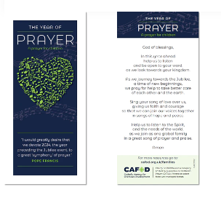 | The Big Lent Walk – Large Outdoor Banner available for the first 200 schools who register. Please note on the registration page it will mention “JustGiving” but your school does not have to use “JustGiving” if you proceed.  Celebrations of the Word for Lent & Holy Week. Lent Resources.  Lent Assembly available from 8th February but watch anytime. School featured is from Bridgend, S.Wales.  Free prayer cards for children (and adults) for 2024 The Year of Prayer. No limit od order.
Primary | MISSION TOGETHER  https://missiontogether.org.uk/teaching-resources/ | Lent Calendar.  Celebrations of the Word  Powerpoints.
Age Range | Web link/Doc. | Details
Primary & Secondary |  | Series of presentations for Lent to purchase.  N.B. FREE download . Ash Wednesday 8 minute presentation available now.
Primary & Secondary | The Jerusalem Trust  https://www.regrants.org.uk/ | Grants up to £600 for Religious education resources.
Primary & Secondary |  | Information re. new translation of the Bible  English Standard Version – Catholic Edition

