PRAYER & LITURGY

A Directory for Prayer & Liturgy is being developed for use in Catholic schools throughout England and Wales.

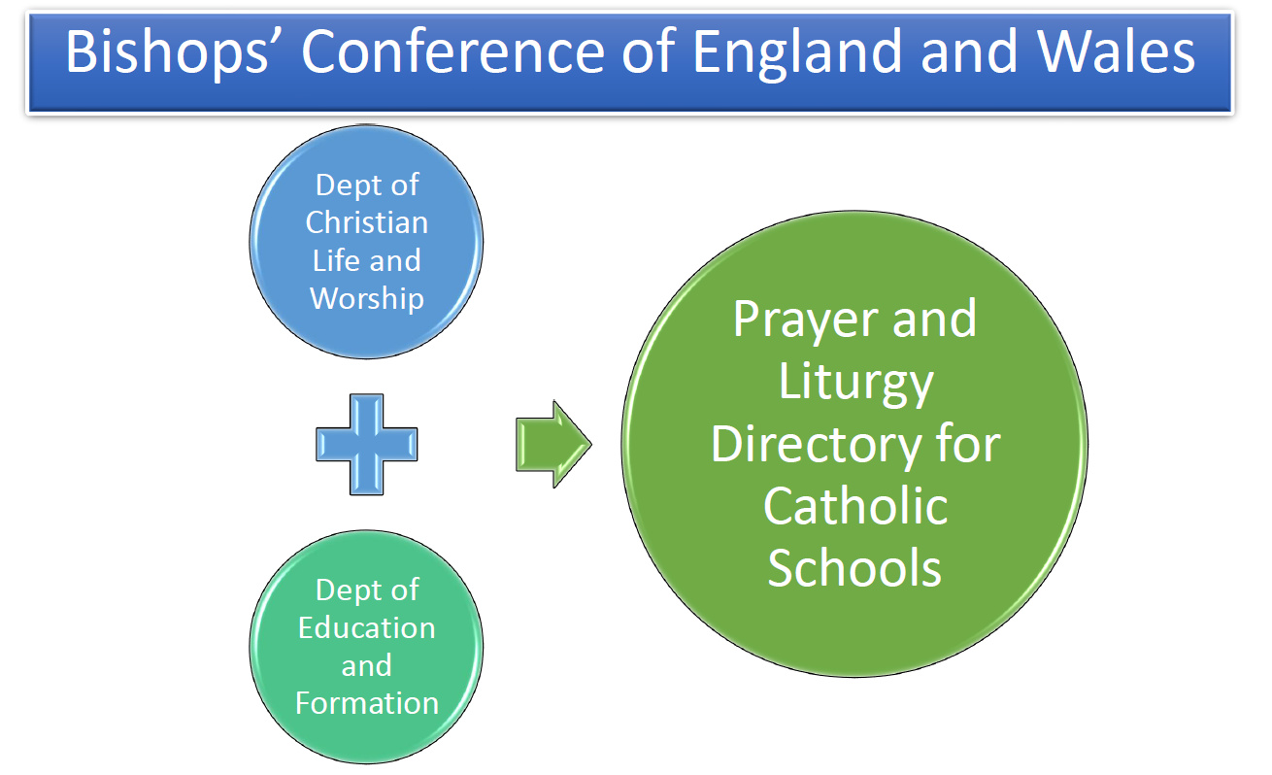

* In Autumn 2019 a Working Partywasput together with representatives from all essential groups (CES, Liturgy Office, NBRIA, ACCE, ATCRE).
* Aim - to create a Directory (approx. 50-60 pages) to support all those responsible in leading Catholic schools (first of its kind).
* The ‘Writers’ are from the Liturgy Office with all members of the Working Party contributing.
* This will support the new Inspection Framework, although its raison d’être is to provide consistent guidance with norms of the Church for prayer and liturgy in schools.

The Directory will set out clearly the principles and norms for **Catholic prayer and liturgy** and their application in the specific context of schools.

It will be based upon the wider **principles and norms** for Catholic prayer and liturgy used in the Church.

The Directory is intended in the first place for all who are directly involved in **overseeing and facilitating** prayer and liturgy in their schools.

It will build on current good practice.

Following consultation, comments will be received and amendments made. Final approval from the bishops will then be sought.

The intention is that it will be published in **September 2021** (alongside the Inspection Framework and RECD) to be **implemented by September 2022**.