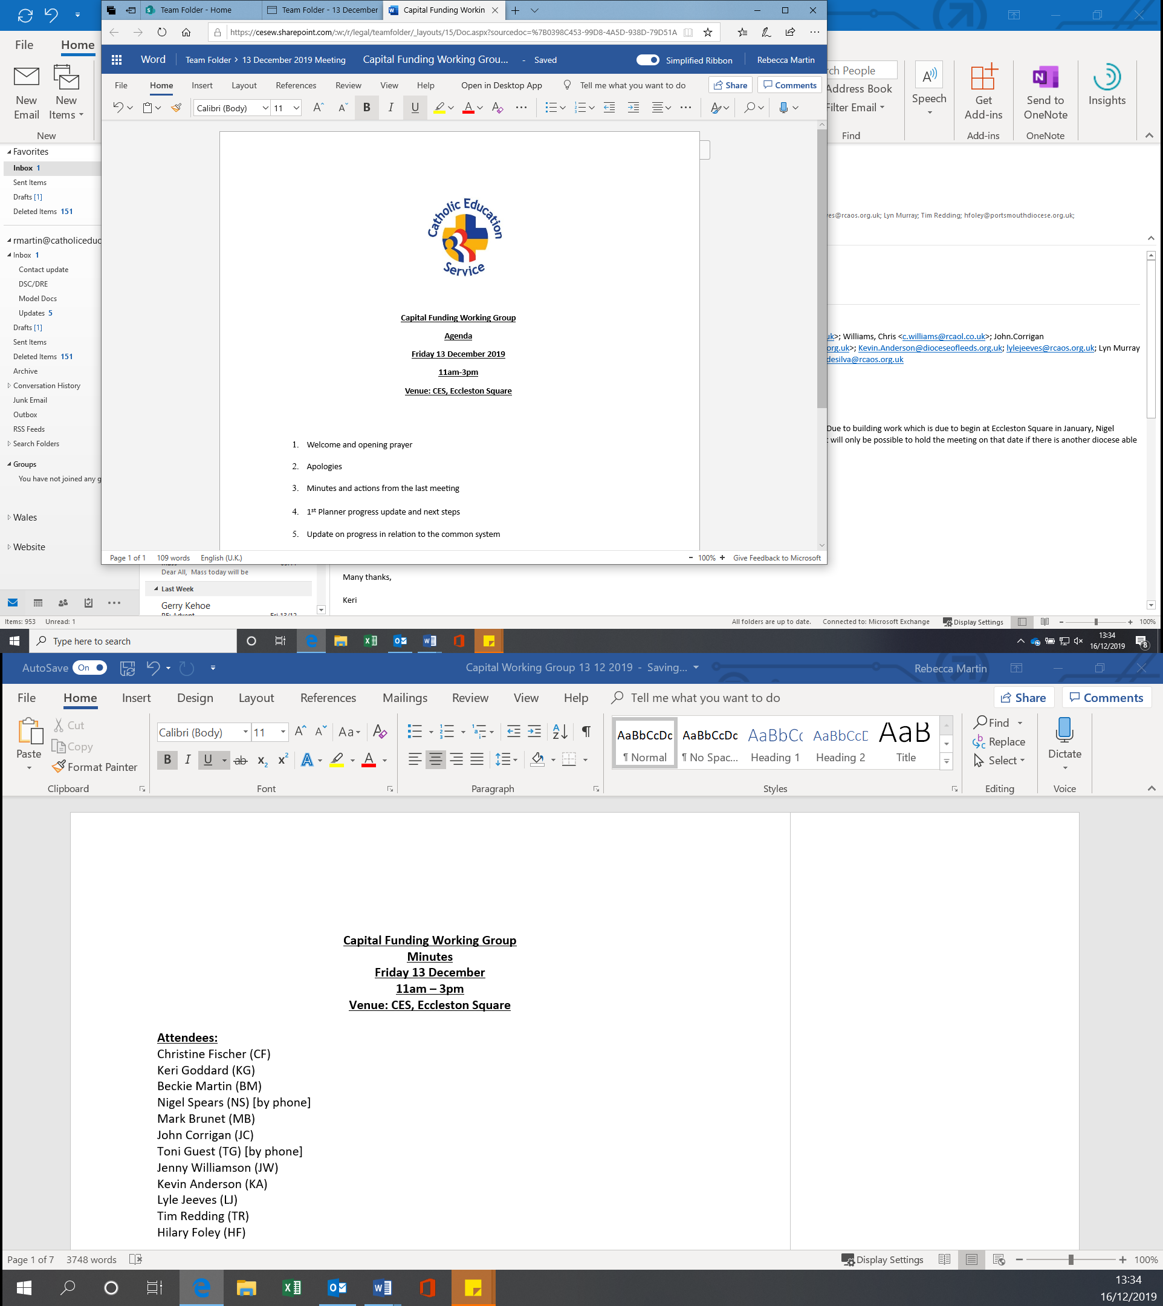

**Summary of survey results**

**Introduction**

The CES recently conducted a survey of Welsh schools in order to gauge the use of CES model policies and contracts in Welsh schools. The survey was sent to headteachers in every school in Wales and it was open from 21 January to 18 February 2021.

Three reminders were sent to recipients to remind them to complete the survey, one at the end of each week the survey was open. There are 84 Catholic schools in Wales, and the CES received 35 responses to the survey representing 41% of Catholic schools in Wales.

The purpose of the survey was to provide the CES with a clearer understanding of the extent of the use of CES model polices and contracts in Welsh schools as many of the documents contain bespoke drafting for Welsh schools and the CES would like to use the information from the survey to assist in the improved allocation of CES resources to Welsh schools in the future.

The full survey results (including the option to download the results in excel format) are available at: <https://forms.microsoft.com/Pages/AnalysisPage.aspx?id=SSQzRY2fT0OpJmB_Xy63KMl0CSQjq-ZIrjVDO9c7VhFUMEdEUkEyVVRZQ1JSMk83VU9JMThTSk5FMC4u&AnalyzerToken=kjM23s3e6dOZyYhjBpaJCwbNp61TjKxZ>

**Survey results**

**Questions 1 and 2 ask respondents to provide the name of their school and LA. We have not provided these details in this summary document, but they can be found in the full survey results via the link above.**

**Question 3 – Which diocese is your school located in?**

20 schools were in Cardiff, 7 in Menevia and 8 in Wrexham.

**Question 4 – Who supplies your school’s sickness absence policy and procedure?**

1 respondent said that they used the CES model policy, 32 used the LA policy, 1 used the regional consortia policy and 1 responded “other”.

**Question 5 – Who supplies your school’s disciplinary policy and procedure?**

2 respondents said that they used the CES model policy, 30 used the LA policy, 2 used the regional consortia policy and 1 responded “other”.

**Question 6 – Who supplies your school’s grievance policy and procedure?**

1 respondent said that they used the CES model policy, 31 used the LA policy, 1 used the regional consortia policy and 2 responded “other”.

**Question 7 – Who provides your school’s capability policy and procedure?**

2 respondents said that they used the CES model policy, 27 used the LA policy, 4 used the regional consortia policy and 1 responded “other”

**Question 8 – Who provides your school’s appraisal policy and procedure?**

3 respondents said that they used the CES model policy, 22 used the LA policy, 8 used the regional consortia policy, and 2 responded “other”.

**Question 9 - If you are not using CES model policies what is the reason for this? (If you are using CES model policies please proceed to question 11.)**

9 responses cited that the LA provides their HR services and insists that they use their policies.

1 response cited union resistance to the CES model policies.

2 responses cited dissatisfaction with the CES model policies.

15 responses cited other reasons which included:

* Using the LA’s policies as part of their service level agreement.
* Close links with the LA and historically always had LA policies.
* Aware of other schools who have used CES policies and had problems.
* LA do not insist but as they provide the HR the Governors adopt their policies.
* GB feel that the LA HR service is strong and best to stay with them.
* LA does not insist but using the policies the HR team are aware of ensures a consistent approach.
* Feels more secure with the legal back up from the county (LA).
* That was what was in place historically.
* Part of FE sector.
* LA advice doesn’t insist, but their advice is based on the LA policy.
* LA provides HR service.
* LA can support the school if there are issues.
* New to post and policies were already in place, unaware if they have considered CES policies.

**Question 10 – If your response to question 9 was “Dissatisfaction with CES model policies” can you explain why you are dissatisfied? (If you did not answer “Dissatisfaction with CES model policies” please proceed to question 11.)**

* The LA has regular training, support and guidance for Heads and Governors, the CES does not offer this. The LA gives great support to Headteachers if issues arise. I am not aware that the CES has the workforce to do this in Wales. Many CES policies relate to an English agenda.
* When I have looked for a relevant policy, it has not covered all the areas expected by the LA.
* It is not dissatisfaction - we use Cardiff HR regularly and they can advise on the policies, how to fill them in, how to deal with sometimes complex cases and are supportive. Equally, these have been agreed with Unions meaning the process is usually easier.
* I would be happy to use CES policies, but HR have raised concerns about some aspects not being 'up-to-date'. I've not been able to answer their concerns, so it has been more expedient to go with LA policies.

**Question 11 – does your school use CES model employment contracts?**

30 respondents answered yes and 5 answered no.

**Question 12 – If your school does not use CES model employment contracts, whose do you use?**

5 respondents reported using LA contracts and 2 reported using contracts from other sources. The two remaining responses were “we’ve just started using CES contracts” and “we use both CES and LA”.

**Question 13 – If your school does not use CES model employment contracts what is the reason?**

* Close links with the LA and historically always had LA contracts and been happy with them.
* The LA does not insist we use their policies but provides HR advice based on their policies.
* We have just started using CES contracts.
* Recently taken over headship so previous contracts and policies were in place already.
* Only recent contracts are CES, and the rest are LA.
* To maintain parity with the schools’ sector
* HT is employed under CES contract. Any future teaching appointments would likely be CES contract.

**Question 14 - If your response to question 13 was “Dissatisfaction with CES model contracts” can you explain why you are dissatisfied? (If you did not answer “Dissatisfaction with CES model contracts” please proceed to question 15.)**

No answers were submitted for this question.

**Question 15 - Is there any feedback you would like to provide to us in relation to the suite of CES model policies and contracts?**

* The website seems to go down a lot but otherwise it is great.
* It would be easier to use all of the same, but because we have an SLA with our LA, we need their support in areas which CES cannot provide.
* The LA have always treated our school well and provide excellent HR/Governance support service. There have been some initial discussions with the LA HR team and Paul White.
* Headteachers need more than policies, they need to know that should they encounter issues then they will be fully supported throughout the process. The LA have so many employees they can do this. I have been a Headteacher for 21 years in Cardiff and at no point has any training on CES policies been offered or has anyone shared with me what support would be given to Headteachers to manage the necessary processes. Also, I am not aware of any CES led Governor Training events that Governors can regularly access. I am not sure how well the policies relate to the Welsh agenda.
* If the policies were easy to locate, concise and matched LA coverage etc, I would happily switch to them but would need to have assurance from LA that we would be fully supported by HR etc if/when challenged over CES policy.
* Schools would need assurance that the LA HR service would provide the necessary support when dealing with capability, disciplinary, grievance issues if CES policies are adopted going forwards.
* Fantastic resource for model contracts.
* Please bear in mind that school systems in Wales are different - LAs are far more involved and that your documentation must reflect the Welsh education system - for example we have no academies, the curriculum is changing drastically from England. The employment contracts work but as things change there may be more divergence.
* It would be useful if the CES policies were in line with LA HR policies to ensure consistency.
* I would like guidance [on] how CES policies can be used instead of, or in conjunction with, LEA policies without disruption to any processe[s] and procedures we are bound to under the SLA.
* It's just difficult sometimes to ensure that the LA are fully familiar with and willing to support the CES policies. We use the sickness absence policy from the LA as they are who supports us with any sickness absences procedures.
* School uses the CES application forms and contracts.
* There are numerous policies, and they are reviewed on a three-year cycle, some policies are adopted by all schools in the cluster and are not CES model policies. CES model contracts have been used for teaching staff but not necessarily for all other staff e.g. ALN TAs etc.
* Please could we have casual ad hoc employment contracts.
* Please note that LA policies relate to one another. This would have to be addressed in CES policies. Also, there are many more LA policies than there are CES ones, so it is not possible to avoid using LA policies altogether.

Conclusion

Whilst the vast majority of Catholic schools in Wales use the CES model contracts, they do not use the model policies. The low level of CES policy usage is problematic because the policies underpin the contracts and give effect to the Bishops’ memorandum.

Several key themes were identified from the survey comments which are worthy of future discussion between the CES and Welsh DSCs:

* There is a disconnect between the reality of the CES model policies and the perception of them. For example, the comments about the law being different in Wales fails to appreciate that the CES produced and consults on separate Welsh policies. The CES policies only apply to schools because the academies regime has not been extended to Wales. The CES believes that work can be done to improve the messaging to schools via dioceses about the Welsh-specific nature of the CES model documents.
* There is concern about the support that LAs would provide were CES model policies to be used.
* The LA policies are broader in scope than the CES policies.

We would invite the dioceses to discuss with the CES their future plans on the use of the model policies and contracts. In particular, whether there will be any change of focus or emphasis in order to encourage the uptake of the CES model policies.