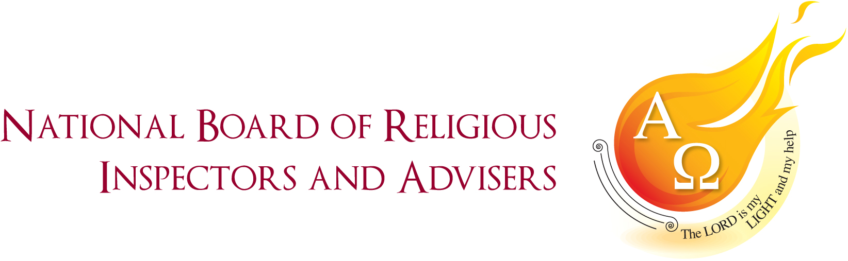

SECONDARY ADVISERS 2022

As a group, we have moved to a balance of live and virtual meetings. Reflection upon the minutes of the last year reveal to one extent, more of the same with regards to CSI, RED, Prayer and Liturgy Directory, and GCSE, but each time with enrichment. CAFOD underpins so much of all we do with ever increasing resources, interactive CPD and robust communications with our dioceses.
We have witnessed and participated in key developments in GCSE. EDUQAS continues to grow from strength to strength in the provision of efficient training and communication across the dioceses. There has also been notable improvement in provision from Edexcel, which is now hosted by experienced practitioners who have the willingness to be proactive and to listen. For AQA we are largely dependent upon the sharing of good practice partnerships between a rising number of diocesan schools.
Much will continue to be said elsewhere about the RED and its imminent publication in January. Suffice to say its development has included massive contributions from advisers in each phase. Our priority is to match and shape the content of existing 11-13 programmes of study.
The group is acutely mindful of the national shortage of teachers of Religious Education. This matter was referred to Executive and DREs. This has resulted in strategies for greater liaison between sixth forms and centres of ITT, including our universities. Another serious issue has been the removal of many ITT programmes due to low take-up. A related issue for action lies in the quality of advertisements, person, and role specifications for heads of Religious Education. Many of these appear to have been prepared from a school HR perspective that seriously lack the canonical requirements. Secondary advisers have therefore been tasked to convene a working group to prepare model specifications, with ongoing advice from the CES legal team.
More than ever, our schools need to be represented on the SACREs. This is of immense importance in Wales, amidst the constant work to safeguard the rights of Catholic schools in response to government legislation. In England we have the double challenge of government legislation and the voice of the Humanist lobby. In response, a SACREs support group has been established to help with recruitment and guidance of our representatives across the dioceses. Much strategic groundwork has been headed by Peter Ward and Amanda Crowley.
The Summer Conference at Hinsley Hall was very well supported. The programme was enriched by a raft of excellent speakers. These included Susan Elderfield on Theology in our Schools from a Black British Perspective. Helen Roberts led us under the title of Dignify – RSE and healthy relationships for students in our Catholic schools. Susan Kambalu encouraged us to Step up to the Plate, CAFODs latest campaign. Teaching Tricky Theology by Paul McHugh was as enlivening as it was thoroughly challenging! Hodder was in attendance to introduce its latest resources. As ever. Philip Robinson contributed so much to our business agenda. We are indebted to him!

In conclusion we pay prayerful tribute to Anthony Towey, who at the start of the Summer Conference, led us in keynote reflection, sharing his signature style of spirituality, presence, and excellence! May he rest in peace!

