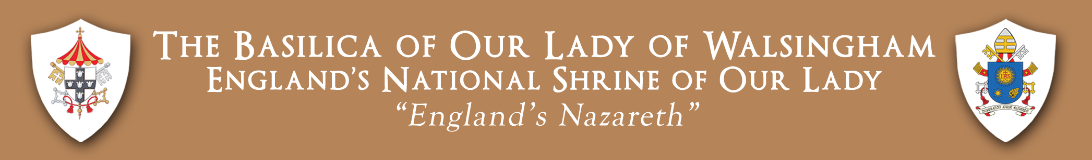

May 2021 Rosary Mission – Briefing Document for Schools
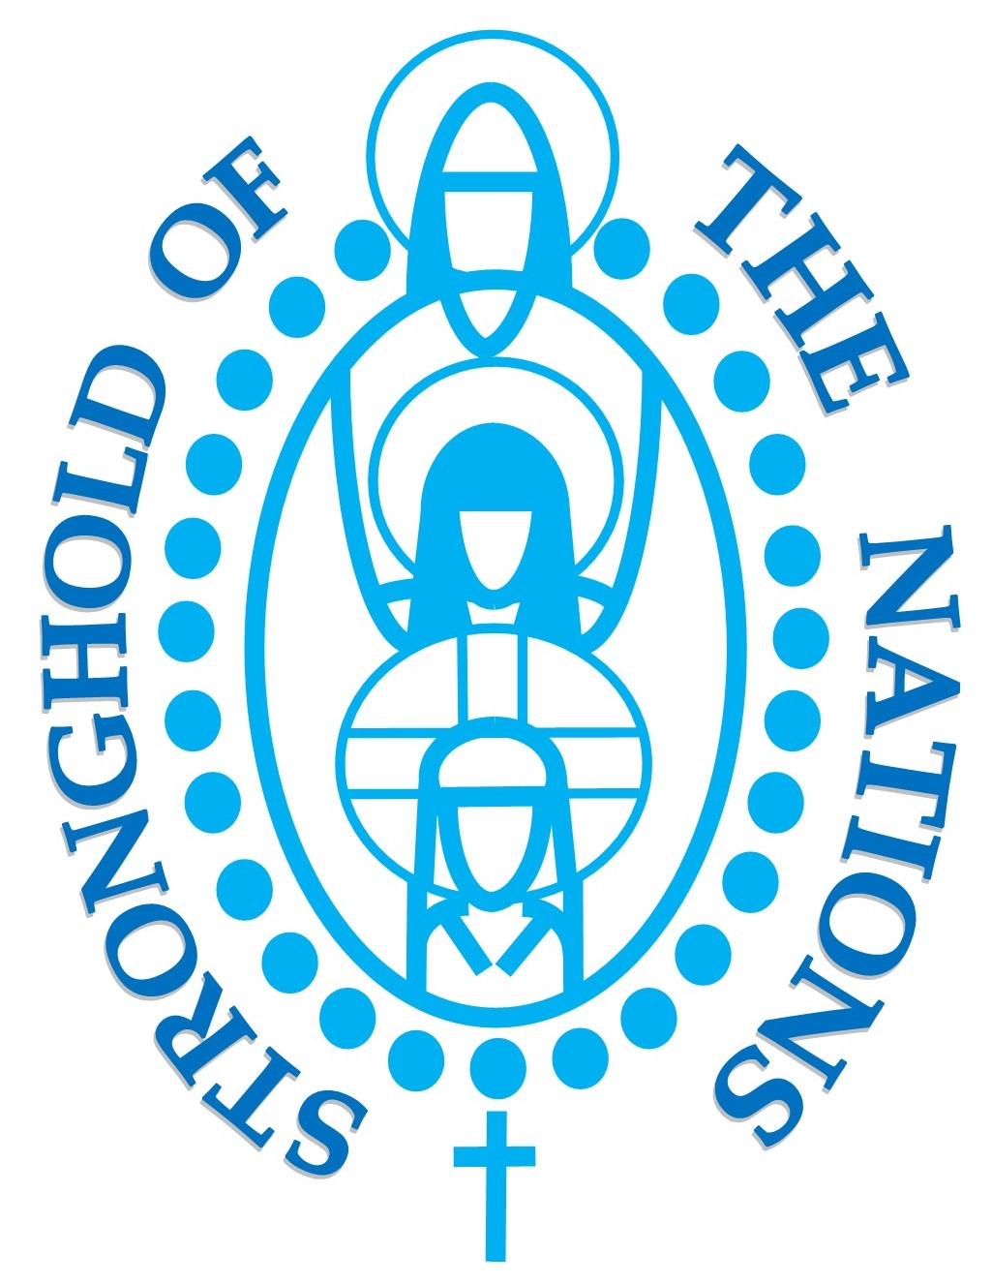

Rosary Stronghold with the Holy Family:
Protecting our Families and the Family of Nations

We invite you to participate in this Rosary Mission in the light of the Rededication of England as the Dowry of Mary on March 29th 2020, the Consecration of Scotland to the Immaculate Heart of Mary on September 3rd 2017 and our prayerful intercession for Wales. Our core intentions are for Faith, Life and Peace and, in this year of St. Joseph, to invoke the special protection of the Holy Family upon our Church, our families, communities, schools, nations and the global family. We continue to pray for deliverance from and the cure of the global pandemic.

We begin on Saturday 1 May, the Feast of St. Joseph the Worker, with our nightly evening 8.00pm online Rosary – to JESUS through Mary, which will be led from various Shrines and Parishes throughout the UK. This nightly Rosary forms the spiritual bedrock of the entire Rosary Mission. We will create in United Prayer before the Lord Jesus, a Rosary Stronghold of protection with the Holy Family upon our Families and the Family of Nations.

This leads us into three important National Days of Prayer.

Monday 24 May, the Feast of Mary, Mother of the Church. We encourage a Rosary Day of Prayer to pray for our beloved Young People – to pray and intercede for the Mission and Intentions of our schools, youth associations, groups/projects, our young people and for families. It is hoped on this day that the Rosary would be encouraged in our schools and that the faithful will form small groups in their churches, homes or outside, always keeping Covid-19 protective restrictions in mind.

Sunday 30 May, the Solemnity of the Most Holy Trinity, we will host a National Rosary Relay Rally throughout the Dioceses of Scotland England and Wales.

Monday 31 May, the Feast of the Visitation – Bishop John Keenan will host a Crowning Rosary online at 8.00pm, in thanksgiving for the graces received from the Lord Jesus through the powerful intercession of Our Lady of the Rosary during the May 2021 Rosary Mission.
Let us place our families, our children and young people, and our nation into the Sorrowful and Immaculate Heart of Our Lady of the Rosary and plead for Her powerful intercession to lead us to a renewed relationship with her Divine Son Jesus, the Saviour of the World.

- While the evening Rosary may not be entirely practical for all young people, we would encourage Primary Schools to continue their usual practice of pupils reciting a decade of the Rosary each day during the month of May. - We would also encourage Secondary Schools to look at practical ways they could participate in the Rosary Stronghold Mission - In addition to the daily recitation of a decade of the Rosary, we would ask schools to mark this day in a special way.

